Power-BI-Projects
Power BI Dashboard Project: Global Superstore Analysis
This repository contains the Power BI Dashboard project that I created using the Global Superstore dataset. The dashboard provides in-depth analysis and visualizations to gain insights into various aspects of the business.
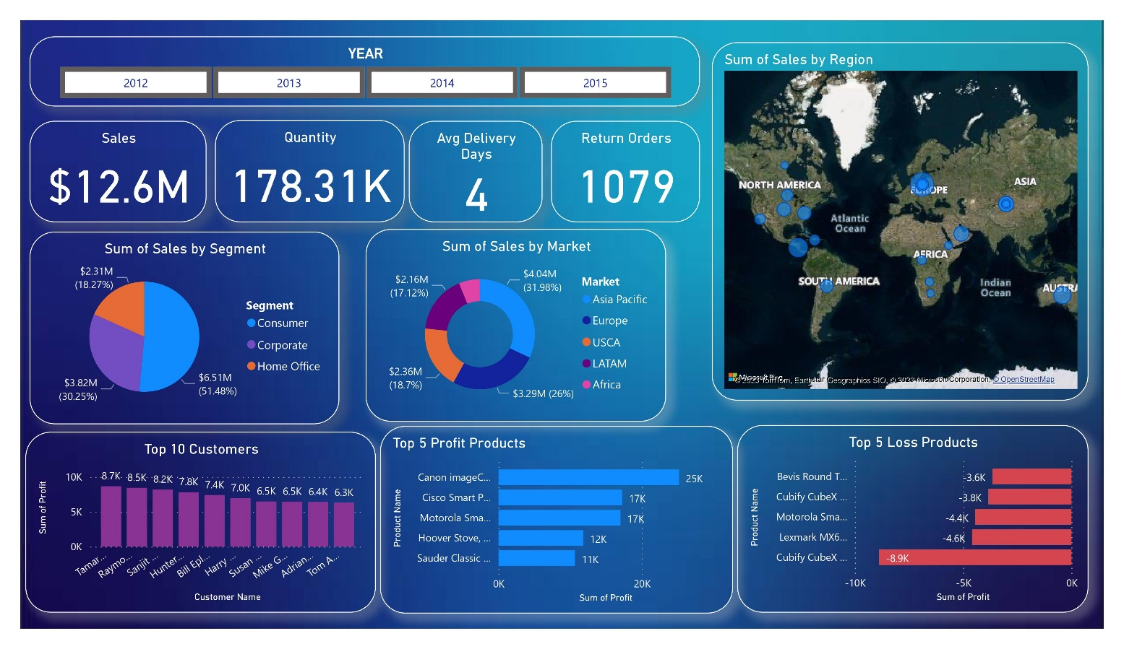
Project Overview
The goal of this project is to leverage Power BI's powerful features and capabilities to analyze and visualize the Global Superstore dataset. The dataset consists of sales data from a global retail company, including information about customers, products, orders, and regions.
Key Features
- Data Integration: Connected the dataset with Power BI Desktop, ensuring seamless integration for efficient analysis.
- Data Analysis: Analyzed tables and established meaningful relationships to uncover insights and correlations within the dataset.
- Data Cleaning: Conducted thorough data cleaning using Power Query Editor, ensuring data accuracy and consistency.
- Data Modeling: Utilized DAX (Data Analysis Expressions) to create calculated columns and measures for enhanced analysis.
- Interactive Visualizations: Developed an interactive BI dashboard/report that brings data to life, enabling users to explore and discover insights.
- Key Metrics: Created visualizations for key metrics such as sales, quantity, average delivery days, and top-profit and loss customers.
- Market and Segment Analysis: Visualized the sum of sales by market and segment to understand the performance across different market segments.
- Regional Analysis: Used map visualizations to analyze the sum of sales by region, allowing for geographic insights.
- Time Slicer: Incorporated a year slicer for dynamic analysis, enabling users to explore data trends over time.

